**pOVémon**

Olivia, an aspiring Povémon master, dreams of conquering the Povémon Arena, where trainers compete using their teams of powerful creatures called Povémon. To achieve this, Olivia needs a reliable system to manage her growing collection efficiently, from building a strong active team for battles to organizing Povémon in storage. Your task is to create **Povémon Arena Simulator**, a software solution to help Olivia manage her Povémon effectively and train for battles.

The system should allow Olivia to view her current team and check the battle status of each Povémon, **swap Povémon between battles, the team, and storage, insert new Povémon into the team while adhering to the team size limit, and organize storage by ensuring no duplicates in the active team**. This tool will empower Olivia to strategize and train effectively, helping her rise to the top of the Povémon Arena. **Focus on the main features. Design will not be scored.**

**Povédex**

|  |  |  |  |  |  |  |
| --- | --- | --- | --- | --- | --- | --- |
| **Name** | **Type** | **HP** | **ATK** | **DEF** | **SPD** | **Price** |
| CharbolT | **FIRE** | 50 | 20 | 20 | 60 | 200 |
| AqualaSh | **WATER** | 44 | 15 | 25 | 43 | 200 |
| TreethIng | **GRASS** | 45 | 20 | 20 | 45 | 200 |
| RUmbleu | **FIRE** | 50 | 25 | 15 | 55 | 750 |
| ACRanix | **WATER** | 40 | 15 | 20 | 45 | 500 |
| VerMarok | **GRASS** | 60 | 30 | 30 | 40 | 1000 |
| MirMage | **FIRE** | 35 | 35 | 15 | 75 | 350 |
| FOscorra | **GRASS** | 45 | 25 | 20 | 50 | 400 |

* **Greetings Menu**
  + **Prompt** the user to input their **name.**
    - **Prompt** the user to **confirm** whether their name is correct or not **(case insensitive)**

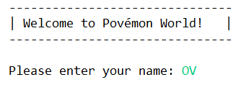

***Figure 1.1. User input name***

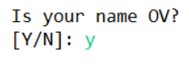

***Figure 1.2. Confirmation (case insensitive)***

* + **Prompt** the user to **choose** their starter Povémon (see the Povémon data in the **Povédex, page 1**) and **show a message after choosing and invalid input**.

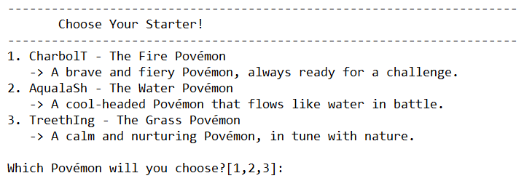

***Figure 2.1. Choose starter***



***Figure 2.2. Starter chosen message***

* **Main Menu**
  + This page contains 4 menus, which are:
    - **Enter Battle**
    - **Enter Shop**
    - **Modify Povémon**
    - **Exit**
  + **Prompt** the user to select an option by **inputting the corresponding number** from the menu **(show a message if invalid input)**

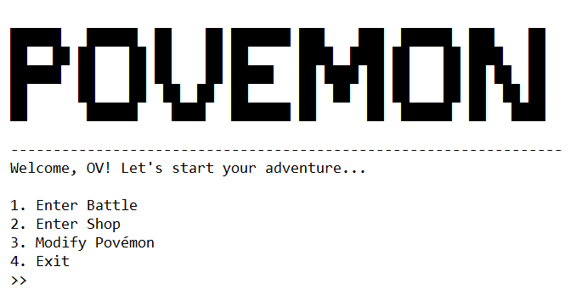

***Figure 3. Main Menu***

* **Enter Battle**
  + **Shows** the following **battle information**:
    - **Opponent’s Name**
    - **Opponent’s Povémon Name, CurrentHP, HP**
    - **Player’s Name**
    - **Player’s Povémon Name, CurrentHP, HP**
  + This page contains 3 options, which are:
    - **Fight**
    - **Run**
    - **Povémon**
  + **Show** the **opponent’s and player’s voice line**. There are different voice lines for **first turn and end of battle (winner and loser voice lines).**
  + **Prompt** the user to select an option by **inputting the corresponding number** from the menu **(show a message if invalid input).**

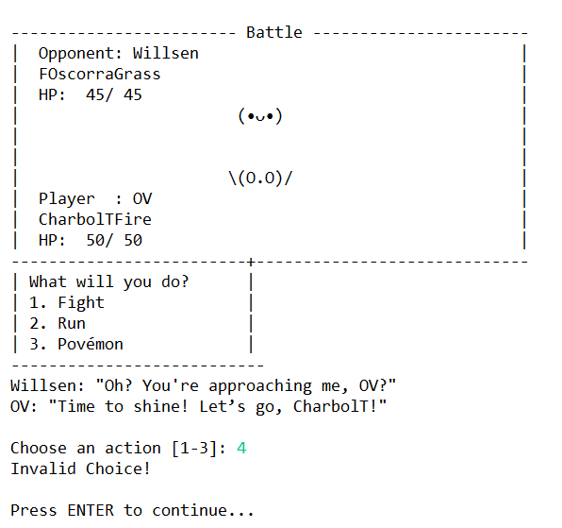

***Figure 4.1. Enter Battle Menu***

* + **Enemy Generation** 
    - **Name →** choose between **5** different names
    - **Money →** calculate using this **formula:**

|  |
| --- |
| **Money = 200 + random [1 – 100]** |

* + - **Povémon Team →** the enemy’s team size is **based on the player’s team** size (eg: if the player has 2 Povémons in their team, the enemy will also have 2 Povémons). **Randomly** choose between the Povémon in the **Povédex**. Make sure there is **no** **duplicate** Povémon in the team.
  + **Fight Option**
    - **Povémon Team →** the enemy’s team size is **based on the player’s team** size (eg: if the player has 2 Povémons in their team, the enemy will also have 2 Povémons). **Randomly** choose between the Povémon in the **Povédex**. Make sure there is **no** **duplicate** Povémon in the team.
    - **Calculate damage →** each Povémon **type** has its **strengths** and **weaknesses**: **Fire beats Grass, Grass beats Water, and Water beats Fire.** Calculate using this **formula** and seeing the **effectiveness** **table**:

|  |
| --- |
| **totalDamage = Attack Stat * Effectiveness** |

**Effectiveness Table:**

|  |  |  |  |
| --- | --- | --- | --- |
|  | **Fire** | **Grass** | **Water** |
| **Fire** | **1x** | **2x** | **0.5x** |
| **Grass** | **0.5x** | **1x** | **2x** |
| **Water** | **2x** | **0.5x** | **1x** |

* + - **Turn Order** → determine turn order by **comparing the speed stat** of the Povémon in **battle.**
    - **Enemy Povémon Switch** → if the current battling Povémon **faints** and the enemy **has others**, switch to the **next Povémon in their team**.
    - **Status Effect** → certain Povémon can be affected by ***Burned*** or ***Poisoned*** status based on their type. The damage is calculated using:

|  |
| --- |
| **BaseBurnDamage = 5** |
| **BasePoisonDamage = 3** |

**Burnable and Poisonable** **Povémon** **list:**

|  |  |
| --- | --- |
| **Burnable** | **Poisonable** |
| **WATER** | **FIRE** |
| **GRASS** | **WATER** |

Damage is **multiplied** based on the Povémon's **type** using the **Effectiveness** **Table** (e.g., Grass type takes 2x Base Burn Damage).

**NOTE:** Use an **interface** to define the *burnable* and *poisonable* status for each type.

* + - **Damage Report** → **display** the amount of damage **each Povémon received** from both the **attack and status effects**.

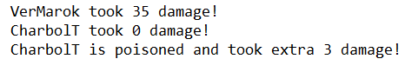

***Figure 4.2. Damage Report Message***

* + - **Player Povémon Faints** →if the **current** **battling** Povémon **faints** and **others are available**, **display** that the Povémon **“has fainted!”** and **prompt** the player to **switch** to another team Povémon **(case insensitive, “0” to cancel)**. **Update** the fainted Povémon's status to **“Fainted.”**

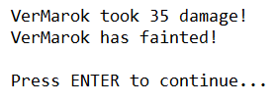

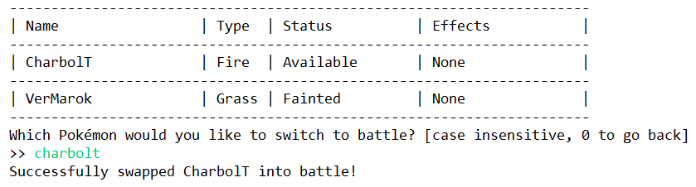

***Figure 4.3. Switch Fainted Povémon***

* + - If **either** the enemy or player **has no remaining Povémon**, **declare the winner**. The **winner receives 75% of the loser's money**, which is **deducted** from the **loser's total**. Then, **display** the winner's and loser's respective **voice lines.**

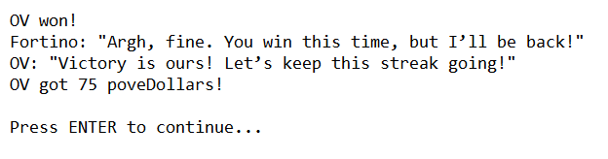

***Figure 4.4. Battle End Message***

* + - **Prompt** the user to start another. If yes, a new battle begins; if no, return to the main menu **(Y/N, case insensitive)**
  + **Run Option**
    - **End** the battle.
    - **Prompt** the user to start another. If yes, a new battle begins; if no, return to the main menu **(Y/N, case insensitive)**

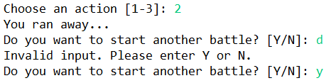

***Figure 4.5. Run Away Message***

* + **Povémon Option**
    - **Show** all the Povémon in the player’s **team.**
    - **Prompt** the user to select a Povémon to switch into battle. If the selected Povémon is not in the player’s **team**, display **“Invalid Choice!”** and **prompt** the user to input again **(case insensitive)**.
    - **Input** “0” to cancel the operation.

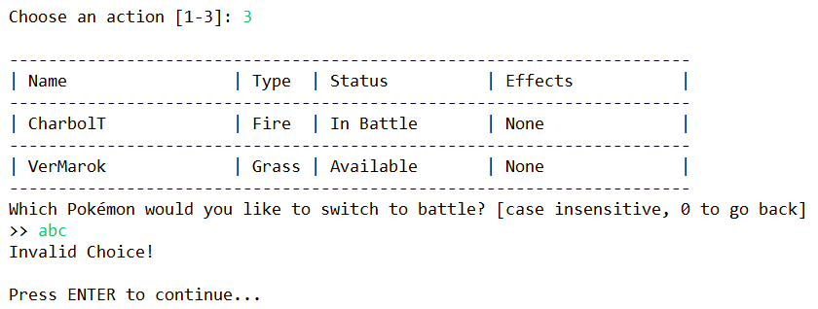

***Figure 5.1. Switch Povemon Invalid Choice***

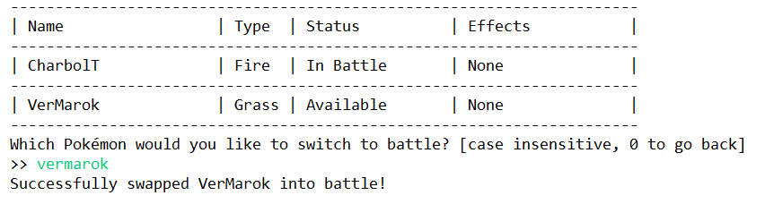

***Figure 5.2. Switch Povemon Valid Choice***

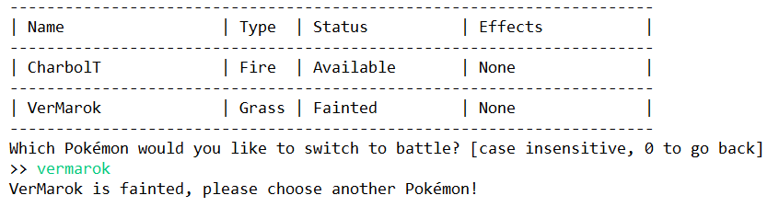

***Figure 5.3. Switch Povemon Fainted Choice***

* **Enter Shop**
  + **Display** all available **Povemon** for **sale.**
  + **Display** **player’s total money.**
  + This page contains 2 options:
    - **Buy Povemon**
    - **Exit Shop**

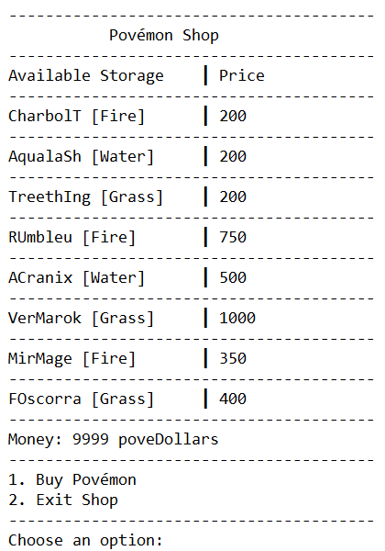

***Figure 6.1. Shop Menu***

* + **Prompt** the user to select an option by **inputting the corresponding number** from the menu **(show a message if invalid input).**
  + **Buy Povemon**
    - **Prompt** the user to select a Povémon to buy. If the Povémon is not in the shop, display **“Povemon not found! Please choose a valid one.”** and return to Shop Menu **(case insensitive, “0” to cancel)**.

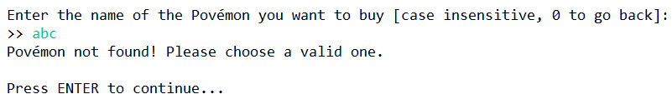

***Figure 6.2. Povemon Not Found in Shop***

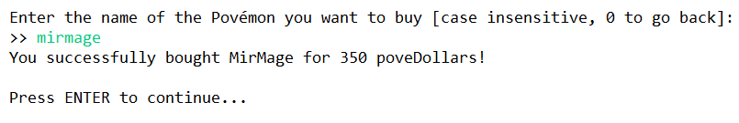

***Figure 6.3. Povemon Found in Shop***

* + - **After** **purchasing** a Povémon, **add it to the player’s Povémon storage** and **remove** it **from** the **shop** **list**.
  + **Exit Shop**
    - **Display “Thank you for visiting the shop!”** and return to Main Menu.
* **Modify Povemon**
  + **Display** all **Povemon** in team and storage (If the povemon is in the player’s team, don’t display it in the Povemon Storage).
  + This page contains 2 options:
    - **Insert Povemon to Team**
    - **Exit**

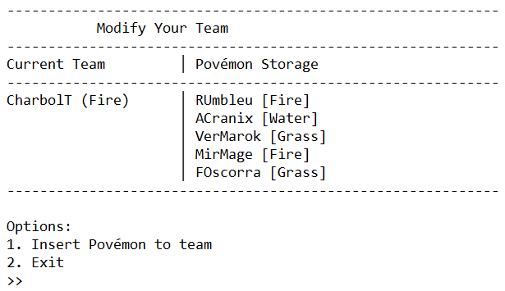

***Figure 7.1. Modify Povemon Menu***

* + Insert Povemon to Team
    - **Prompt** the user to input the **name** of the Povémon they want to **move from storage** to their team **(case insensitive).** Enter "0" to cancel. If the Povémon is not found in storage, **display** **“This Povémon is not in your storage!”.**

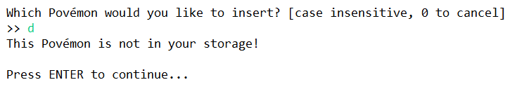

***Figure 7.2. Insert Failed***

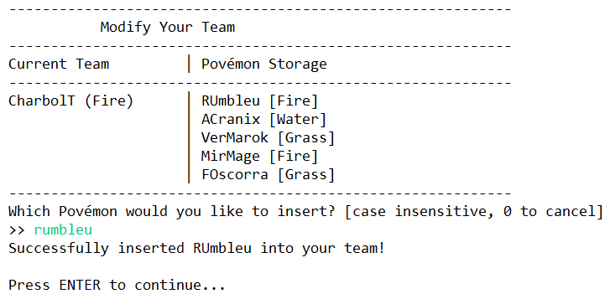

***Figure 7.3. Before Inserting VerMarok into Team***

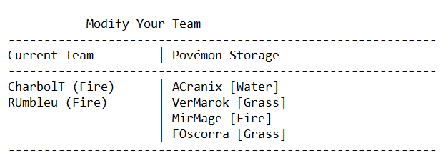

***Figure 7.4. After Inserting VerMarok into Team***

* + - **Exit** → **Return** to Main Menu.
  + Exit
    - **Display** Exit Menu and end the program.

**Please ask your teacher or teaching assistant if there are any related questions.**